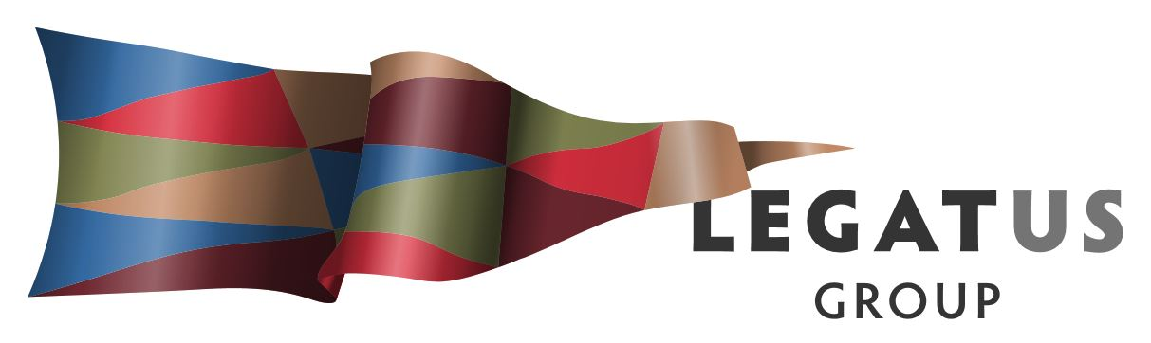

Legatus Group CWMS Advisory Committee
Tuesday 26th May 2020
10.00 – 11.30 am
Via zoom
https://us02web.zoom.us/j/86336446177
Meeting ID: 863 3644 6177
Password: 059144

AGENDA

- Welcome and apologies
Andrew MacDonald Chair

- Previous Minutes
Draft Minutes from the meeting of the Legatus Group CWMS Advisory Committee (the Advisory Committee) on 6th March 2020 are attached:

- Matters Arising
3.1 Proposed CWMS training course
The Advisory Committee previously sought further information, including estimating demand for the course, its scope and possible funding.

The scope of the course would include operational and compliance training and be set by the typical features of CWMS in South Australia. An outline of the course is attached.

SA has many small, isolated plants, its own regulatory regime and it lacks a State-wide CWMS organisation as exists in other States. These differences make it impractical to seek formal, national accreditation from Australian Industry Standards under the Australian Qualifications Framework and the course would instead be state-based and accredited by the LGA. Funding to develop the course is being pursued with the SA Department of Innovation and Skills and the LGA. Much of the course content can be developed by Legatus in conjunction with the LGA but there is also a need to identify experienced operational personnel to provide content for the operational training.

It is recommended that the Advisory Committee note the progress with the proposed course and suggest names of experienced personnel who might be approached.

3.2 Asset management by remote sensing proposal
At the last meeting, the Advisory Committee sought further information regarding the costs and contributions of the parties to this proposal, being Legatus and Councils, UniSA and the independent company, IPACS. That has required a clearer definition of the project, which is now detailed in the attached draft proposal that has been shared with other parties. Legatus Project Officer will brief the Advisory Committee on the stated positions of the parties and Matt McRae will also brief members on the position of his Council.

The views of Advisory Committee are sought on the draft proposal.

- Feedback from CWMS Communications Sessions
Legatus is supporting the LGA in hosting CWMS Communications Sessions for Council staff each month in each Regional LGA. One was held for Riverland and Murraylands on 29th April and another is scheduled for the Eyre Peninsula on 27th May, with others to follow until August. The sessions focus on issues such as training, equipment, reporting and planning. As the sessions take place, a consolidated list of issues will be developed.

The Legatus Project Officer will inform members at the meeting of anecdotal evidence pointing to recurring themes including a lack of clarity about Council’s legal obligations when using private operators, difficulties in responding to issues raised in audits by OTR and the great variety of arrangements among Councils with some, small Councils which operate single Schemes lacking in resources and skills and many Councils having limited costing and investment analyses.

This item is for noting and further feedback from the Communications Sessions will be provided at subsequent meetings.

- Proposal for PhD Internship looking at capital expenditure
At its January meeting, the Legatus Regional Management Group considered the proposed CWMS work plan and suggested that it include consideration of capital expenditures in addition to the work being done on operational matters. Some of that focus is provided by the asset management proposal (item 3.2 above) but it is proposed that further work be undertaken, making use of the PhD internship program.

It is proposed that work be undertaken to determine what is the optimal technology and design for a greenfield application typical of the Legatus Group region. The work would look at the impact that small scale and isolation has on optimal wastewater treatment plant. It would make recommendations for future investment and upgrades.

The views of the Advisory Committee are sought on the proposal.

- Alternative Business Models for CWMS in regional South Australia
At its January meeting, the Legatus Regional Management Group received a presentation of a personal view from the Project Officer which discussed the possibility of changing the ownership and management of CWMS away from the current position where Councils predominate in nearly all cases. The presentation had also been provided to a meeting of Regional LGA Executive Officers which supported further discussions. The Legatus Regional Management Group asked that a short, one-page briefing be prepared and considered by the Advisory Committee prior to their receiving it. The briefing is attached here:

It is recommended that the Advisory Committee makes comments and suggestions on the briefing paper.

- Cross-Council collaboration

The Advisory Committee agreed to reconsider this item, aiming to assess the potential value of collaboration and to indicate areas where Legatus might help. This matter intersects with previous discussions regarding alternative business models. Again, the Advisory Committee is asked to reflect on the issue of Councils’ go-it-alone attitude and the role of Legatus in fostering collaboration.

It is recommended that the Advisory Committee considers means to better coordinate regional CWMS in South Australia, including by establishing a State-wide, specialist organisation and examining alternative business models.

- Other business
  - 2020 CWMS Conference
The Legatus Group CEO will speak to this matter and seek the views of the Advisory Committee members on timing, speakers, topics, etc.

  - Legatus Group Regional Sludge research
In 2019, the Legatus Group conducted research into the viability of a regional sludge processing plant. It concluded that quantities of sludge and septage were too low for the plant to be viable but that a larger facility, processing more kinds of biosolids might be.

The report also raised questions about sludge: “the quality characteristics of sludge and septage are critical to any management regime… (but) … Councils do not comprehensively test the sludge from their ponds, … they have no information on the quality of septage… (and) … there is no … follow up testing..” The research plan agreed subsequently between UniSA and Legatus identifies research discerning the characteristics of CWMS sludge.

The Advisory Committee is asked to consider the best way to progress this research.

  - Drought Futures Fund Project/s
There are two projects currently being considered. The first is a system which harvests stormwater runoff from urban roads to irrigate street trees. Inlets are installed in the kerb, connected to an infiltration trench or ‘leaky well’ which detains the water until it soaks into the nature strip. The project aims to determine the effectiveness of the system.

The second is a SA Water initiative to optimise irrigation of public open spaces using a proprietary software which generates precise irrigation schedules. Participating Councils receive information on a dashboard which advises them on irrigation allocations.

These may also have the ability to link with item 8.2 and other CWMS initiatives to assist with a broader regional project.
These matters are for noting only.

  - Coronavirus monitoring in regional CWMS
An initiative has been underway to track the spread of the virus by monitoring sewerage, including from CWMS. A verbal briefing on the situation will be provided at the meeting.
- Date of next meeting

- Close

