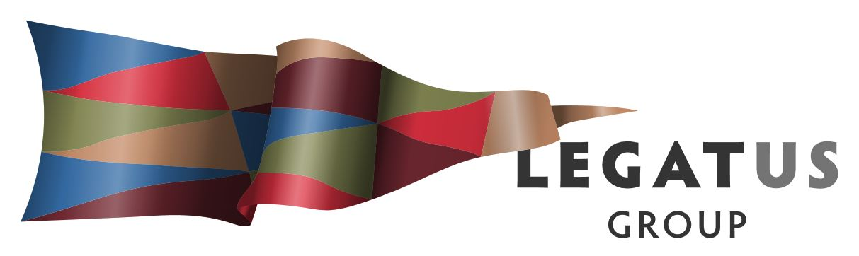

AUDIT & RISK MANAGEMENT COMMITTEE MEETING

Tuesday 30 April 2019 10.00 am

Location: Teleconference

Notice is hereby given that the next Audit & Risk Management Committee meeting of the Legatus Group will be held on Tuesday 30 April 2019, commencing at 10.00am via teleconference: Phone 1800 064278 PIN 21159013

Contents

1. Meeting attendance and apologies 3
2. New member and appointing chair 3
3. Minutes of previous meeting 3
4. Business arising not otherwise of the agenda 5

4.1 Exemption of having an audit committee

4.2 Chair / membership

4.3 Banking / credit card

1. Work Plan 6

6. 2018/2019 Budget update 7

7. Business Plan / Budget 2019/2020 8

1. Other Business 9
   1. Brighter Futures
2. Next meeting 9

# MEETING ATTENDANCE AND APOLOGIES

**Meeting Attendance**

**Present**

Chairman Kathie Bowman District Council of Orroroo Carrieton

Mayor Denis Clark Northern Areas Council

Mr Peter Ackland CEO Port Pirie Regional Council

Mr Ian McDonald Independent

**Apology**

Nil

**In Attendance**

Mr Simon Millcock CEO Legatus Group

1. **NEW MEMBER AND APPOINTMENT OF CHAIR FOR THE MEETING**

The Legatus Group Ordinary meeting held on 15 February 2019 appointed Mr Ian McDonald to the committee as the non-board member with financial experience relevant to the functions of the Audit & Risk Committee. He joins current members Chairman Kathie Bowman, Mayor Denis Clarke and CEO Peter Ackland.

There has been no other appointment for the current vacant position to the Legatus Group Audit and Risk Management Committee and the role of Chair is vacant. The meeting is required to appoint a chair.

Note the terms of reference requires 3 members of the committee to be present to form a quorum of the Legatus Group Audit and Risk Management Committee.

1. **MINUTES OF PREVIOUS MEETING**

Chairman Kathie Bowman provided a report with the agenda to the Legatus Group meeting on 15 February 2019 which contained the minutes (listed below) of the Audit and Risk Management Committee meeting 30 January 2019. The following motions were carried by the board:

1. That the Legatus Group notes the audit committee’s motions regarding:
   1. The appointment of Ian McDonald to the Legatus Group Audit and Risk Management Committee subject to the committee continuing.
   2. Noting of the budget update and the report on the expression of interest for the delivery of a Northern & Yorke Coastal Management Action Plan.
   3. Their support to the proposed motion by Mayor Lange as outlined in the letter from the Barossa Council for the exemption by the Minister of the Legatus Group having an audit committee if the board is satisfied it has adequate controls and oversights in its structure.
2. That the Legatus Group appoint Dean Newberry & Partners as their independent auditors for the 2018/2019 financial year.

The meeting was opened at 10.05am on 30 January 2019.

1. Meeting Attendance

Present: Via telephone Chairman Kathie Bowman, Mayor Denis Clark and Mr Peter Ackland (item 3.6.3 of the Legatus Group Charter allows for telecommunications to constitute a meeting).

In Attendance: Legatus Group CEO Mr Simon Millcock

Apologies: Nil

2. Membership / Chair

The meeting noted that a quorum for the Legatus Group Audit and Risk Management Committee is 3 members.

Motion: That Chairman Kathie Bowman chair the meeting.

Moved: Mayor Clark Seconded: Peter Ackland CARRIED

3. Confirmation of Previous Minutes

Motion: That the minutes of the previous Legatus Group Audit and Risk Management Committee meeting held on 30 November 2018 be taken as read and confirmed

Moved: Chairman Bowman Seconded: Peter Ackland CARRIED

4. Business Arising Not Otherwise on the Agenda

4.1 Membership

Motion: That Ian McDonald be appointed to the Legatus Group Audit and Risk Management Committee subject to the committee continuing.

Moved: Mayor Clark Seconded: Peter Ackland CARRIED

4.2 Auditor

Motion: That the Legatus Group Audit and Risk Management Committee recommend that the Legatus Group appoint Dean Newberry & Partners as their independent auditors for the 2018/2019 financial year.

Moved: Mayor Clark Seconded: Peter Ackland CARRIED

4.3 Banking Credit Card

Motion: That the Legatus Group Audit and Risk Management Committee notes the report.

Moved: Mayor Clark Seconded: Peter Ackland CARRIED

5. Work Plan

No report

6. Budget Update 2018/2019

General discussion on the increasing surplus and noted:

* Previous recommendations including the potential allocation of some of these funds to road and transport infrastructure programs.
* The need to review considering the forecasted reduction of income from the Rubble Royalties payments and funding from LGA.

Motion: That the Legatus Group Audit and Risk Management Committee notes the budget update and the report on the expression of interest for the delivery of a Northern & Yorke Coastal Management Action Plan.

Moved: Mayor Clark Seconded: Chairman Kathie Bowman CARRIED

7. Other Business

Audit Committee Exemption

The meeting discussed the letter from the Barossa Council outlining the background and their resolution for Mayor Lange to present a motion to seek an exemption from the Minister for the Legatus Group having an audit committee if the board is satisfied it has adequate controls and oversights in its structure.

Motion: That the Legatus Group Audit and Risk Management Committee supports the proposed motion by Mayor Lange as outlined in the letter from the Barossa Council.

Moved: Peter Ackland Seconded: Chairman Kathie Bowman CARRIED

8. Next meetings

Noted that next Audit and Risk Management Committee meetings for 2019 are 24 April and 16 August.

Meeting Closed at 10.29 am

**Recommendation: That the minutes of the Legatus Group Audit & Risk Management Committee Meeting held on 3 August 2018 be taken as read and confirmed.**

# BUSINESS ARISING NOT OTHERWISE ON THE AGENDA

* 1. **Exemption from having an audit committee**



**Recommendation: For noting.**

The Legatus Group meeting 15 February 2019 motion was: “That the Legatus Group supports an application to the Minister for an exemption from the requirement in clause 30 of Schedule 2 of the Act to establish an audit committee subject to receiving a resolution from all constituent councils supporting this application.” All councils were approached and the District Council of Mount Remarkable provided the attached response that they did not support an exemption.



As such an application for an exemption under sub regulation (1) cannot occur.

* 1. **Chair/Membership**

Reports for Discussion

From: Simon Millcock

Chief Executive Officer

**Recommendations:**

1. **That the Legatus Audit and Risk Management Committee recommends the appointment of (name member) as its Chair.**
2. **That the Legatus Audit and Risk Management Committee notes the current vacancy of a professionally qualified officer from a constituent council other than Port Pirie Regional Council and Flinders Ranges Council and request that the Legatus Management Group recommend a one of their members be appointed.**

**Background:**

The Legatus Group Ordinary Meeting held 14 December 2018 delegated authority to the Legatus Group Audit and Risk Management Committee to fill the vacancy for a professionally qualified officers from a constituent council other than Port Pirie Regional Council and Flinders Ranges Council.

The Legatus Group CEOs were canvassed for nomination from a professionally qualified officer from a constituent council (apart from Port Pirie and Flinders Ranges) to fill the current vacancy on the committee.

To date there has been no nominations received from a professionally qualified officer from a constituent council. This matter will be an agenda item for the next Legatus Group Management Group meeting on 1 February 2019.

There is currently no nominated Chair for the Legatus Group Audit and Risk Management Committee.

* 1. **Banking / Credit Card**

Reports for Discussion

From: Simon Millcock

Chief Executive Officer

**Recommendations: That the Legatus Group Audit and Risk Management Committee notes the report.**

**Background:**

The Legatus Group Ordinary Meeting held 14 December 2018 approved:

1. That the Legatus Group CEO Simon Millcock be issued with a Legatus Group corporate credit card with a $1,000 a month limit and in compliance with the Legatus Group credit card policy and that a report be provided on the expenditure as an agenda item at Legatus Group meetings.
2. The transfer of banking from Bank SA to The Flinders Ranges Community Bank Agency.

Following several delays, the transfer is occurring and the Legatus Group CEO has been advised that he has been approved a credit card which has yet to arrive.

1. **WORK PLAN**

Reports for Discussion

From: Simon Millcock

Chief Executive Officer

**Recommendations: That the Legatus Group Audit and Risk Management Committee approves the report on its work plan for 2018/2019.**

**Background:** Work plan attached.



1. **BUDGET UPDATE 2018/2019**

Reports for Discussion

From: Simon Millcock Chief Executive Officer

**Recommendations: That the Legatus Group Audit and Risk Management Committee notes the budget update which will include the Northern & Yorke Coastal Management Action Plan and Youth into Volunteering projects.**

**Background**

The following financial reports 1 July 2018 till 30 March 2019 were distributed to all Board Members and CEO’s on 8 April 2019 as the 3rd quarter financial report.

Attached are the following:

* Profit and Loss
* Profit and Loss – By Month
* Profit and Loss – By Job (Project) – this one is an A3 landscape report
* Balance Sheet
* Movements in Equity
* Cash Flow Statement (this one considers the LGFA Short Term investment account as investments as opposed to cash which it should ideally be)

The Finance Officer has provided the following information:

Payroll side of Xero does not appear to be handing annual leave properly (expenditure for year is only showing as $1778) and the finance officer is looking into setting this up and correcting. The account transaction report shows the transactions in the various accounts. Income accounts start at the bottom of page 28 at account number 41000. The account names are shown on the right-hand side of the report. This helps with any specific questions about what makes up the different totals in the other reports.



The Legatus Group CEO sought clarification on these reports with the following answers provided:

* A/C 61009 Professional Development Line YTD $18263.64 – 3 transaction in there as follows – large amount was for the emerging leaders program RDA Yorke and Mid North which went to Job P030

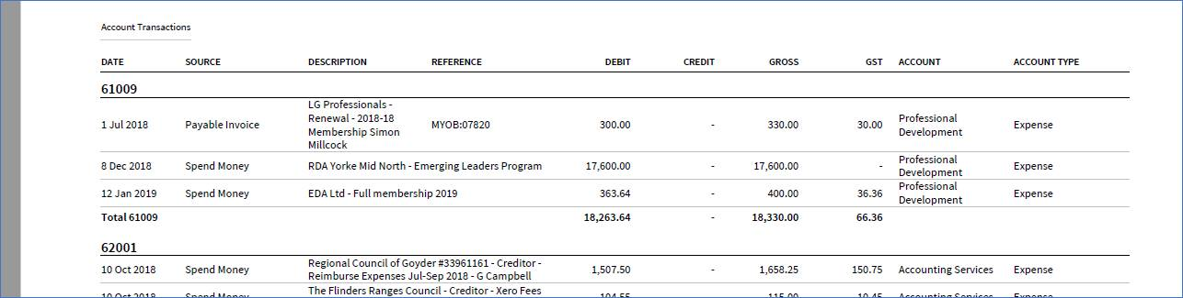

* Rent / Hire of Premises – adopted budget shows as $18,000   but Xero budget is showing as $28,000. Looking through the budget file here that Griff/Colin had, it would appear that the amount of $28,000 if made up of the $18,000 in the admin job and an amount of $10,000 from the special projects job number A009.  The P&L statement (primary one) includes or consolidates all jobs.

The attached report above gives an illustration of this (on the actual expenditure side) where the total across all jobs should be the same as the total shown on the primary P&L report

Income and expenses continue to be on track and as outlined in previous reports income will exceed the budget and this will result in exceeding the forecasted budget profit.

One of the intern rebates earmarked for 2019/2020 is likely to occur in 2018/2019 but this will be used against the Northern & Yorke Coastal Management Action Plan.

Two contracts have been signed which will have impact on the 2018/2019 and 2019/2020 budgets:

1. Building Better Regions Fund – Community Investment Stream – Round 3 Grant - $17,000 for Building a culture for encouraging regional youth into volunteering. This project does not commence until 1 May 2019 and the income is capped at $8,500 for both years.
2. Northern and Yorke Natural Resources Management Board – $128,000 for Northern and Yorke Coastal Management Action Plan. This will include $100,000 income in 2018/2019 and $28,000 in 2019/2020. This project has commenced with Greening Australia and Brian Hales being contracted to assist in its delivery.
3. **BUSINESS PLAN AND BUDGET 2019/2020**

Reports for Discussion

From: Simon Millcock Chief Executive Officer

**Recommendations: That the Legatus Group Audit and Risk Management Committee notes the draft 2019/2020 business plan and budget and that it is to be distributed in keeping with the Legatus Group Budget.**

**Background**

Before the 2019/2020 business plan can be adopted it requires consultation with the constituent councils and year the Legatus Group must prepare and submit a draft budget to the constituent councils for the ensuing Financial Year.

Both the business plan and the budget will be distributed following the Audit and Risk Management Group meeting which will comply with the Legatus Group’s charter so they can be presented to the Legatus Group ordinary meeting to be held on 31 May 2019. Attached is the draft business plan and the draft budget will be provided prior to the meeting.



1. **OTHER BUSINESS**

**8.1 Brighter Futures Flinders Ranges / Orroroo region**

Reports for Discussion

From: Simon Millcock

Chief Executive Officer

**Recommendations: That the Legatus Group Audit and Risk Management Committee recommends the allocation of $5,000 from the Legatus Group budget towards the delivery of a Brighter Futures Flinders Ranges / Orroroo region program.**

**Background:**

The Legatus Group CEO was approached by the Regional Coordinator, Engagement and Grants, Community Services from the Department of Human Services SA Government re funds of $15,000 being available in their 2018/2019 budget for expanding further programs in the Legatus Group region. This was on the back of their delivery of the Brighter Futures projects in Peterborough and the expansion into the Hummocks/Barunga Ranges program.

These are trial projects by the Department of Human Services and these grassroots community development and grants schemes are helping our communities to build skills for grants and community projects and are delivering projects that benefit their community.

The Legatus Group’s strategic plan includes goal two to support social infrastructure and community services that meet the region’s needs.This includes actively working with regional providers to gain knowledge to assist with advocating for improvement of health, education, community and social support services.

Discussions were held with the Flinders Ranges and Orroroo Council Mayors and CEOs to consider a partnership approach. An offer by the Legatus Group CEO to provide in-kind the administrational requirements along with a cash contribution of $5,000 and both councils would look to fund a minimum of four projects (2 per council) each to the value of up to $2,000 for their communities was made.

This proposal has been accepted in principal by the Department of Human Services and final contractual arrangements will need to occur for this project to commence.

The Brighter Futures program will be included in the 2019/2020 Legatus Group’s Business Plan and as part of our three-year action plan and the Legatus Group CEO is seeking to discuss extending a partnership with the SA Government to help make this happen.

# NEXT MEETINGS

**Recommendation:** That the next Audit and Risk Committee meetings is set for Friday16 August 2019 venue to be confirmed.