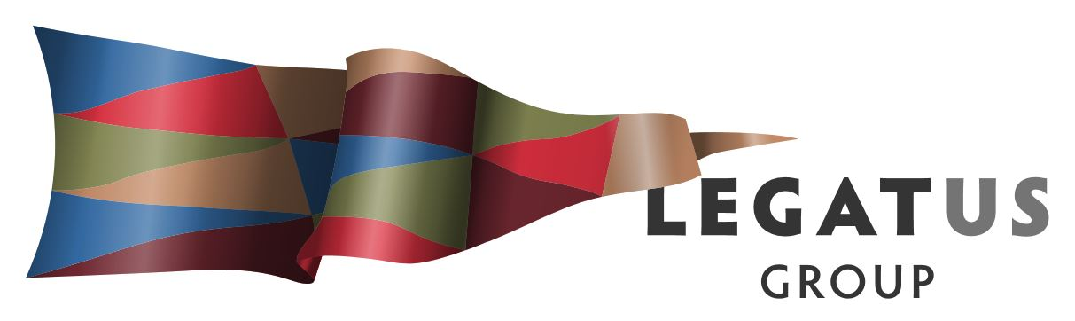

Minutes of Audit and Risk Management Committee Meeting held:
30 November 2018
Council Chamber District Council of Mount Remarkable
The meeting was opened at 10.00am on 30 November 2018 at the Council Chamber, District Council of Mount Remarkable, 3 - 5 Stuart Street, Melrose.
- Meeting Attendance
Present: In person - Chairman Kathie Bowman and Mr Colin Davies and via telephone Mr Peter Ackland (item 3.6.3 of the Legatus Group Charter allows for telecommunications to constitute a meeting).
In Attendance: Legatus Group CEO Mr Simon Millcock
Apologies: Nil
- Membership / Chair
The meeting noted that a quorum for the Legatus Group Audit and Risk Management Committee is 3 members. Colin Davies declared a conflict of interest with regards dealing with financial matters due to The Flinders Ranges Council undertaking the financial management for the Legatus Group. He would refrain from comment or voting on financial matters but would remain within the meeting to ensure a quorum was present.
The meeting noted that the former members Chair Ray Agnew and committee member Colin Nottle was not elected as Mayors in the recent council elections. As such neither are board members of the Legatus Group and no longer members of the Legatus Group Audit and Risk Management Committee.
Motion: That Chairman Kathie Bowman chair the meeting.
Moved: Colin Davies Seconded: Peter Ackland CARRIED
Motion: That the Legatus Group delegate authority to the Legatus Group Audit and Risk Management Committee to fill the vacancy for the one person who is not a member of the Board and who is determined to have financial experience relevant to the functions of the Audit & Risk Committee.
Moved: Peter Ackland Seconded: Colin Davies CARRIED

Motion: That the Legatus Group appoints an elected member of Council to fill the current vacancy.
Moved: Peter Ackland Seconded: Colin Davies CARRIED
Motion: That the appointment by the board of the Chair for the Legatus Group Audit and Risk Management Committee awaits new members being appointed.
Moved: Peter Ackland Seconded: Colin Davies CARRIED
- Confirmation of Previous Minutes
Motion: That the minutes of the previous Legatus Group Audit and Risk Management Committee meeting held on 3 August 2018 be taken as read and confirmed
Moved: Peter Ackland Seconded: Colin Davies CARRIED

Business Arising Not Otherwise on the Agenda
Noted that The Flinders Ranges Council have commenced the financial management services to Legatus Group.
- Work Plan

  - Work Plan Update

Motion: That the Legatus Group Audit and Risk Management Committee notes that the work plan is up to date.

Moved: Colin Davies Seconded: Peter Ackland CARRIED

  - Annual review of all committees

Motion: That the Legatus Group Audit and Risk Management Committee supports the Legatus Group continuing with the Audit and Risk Management Committee subject to the appointment of replacements to current vacancies and for the continuation of the Road and Transport Infrastructure Committee and the CWMS Advisory Committees.

Moved: Chairman Kathie Bowman Seconded: Colin Davies CARRIED

- Budget Update 2018/2019

Mr Colin Davies noted his conflict of interest and refrained from discussing or voting.
The meeting noted the budget update by the Legatus Group CEO and the new format provided by The Flinders Ranges Council.
Motion: That the Legatus Group Audit and Risk Management Committee notes that if the Transport and Road Infrastructure Committee recommend funding from this year’s budget of $35,000 towards projects there is sufficient funds available for this to occur within this year’s budget.
Moved: Peter Ackland Seconded; Chairman Kathie Bowman CARRIED
- EQUITY/RESERVES
Mr Colin Davies noted his conflict of interest and refrained from discussing or voting.
The meeting noted the report by Legatus Group CEO with regards to the previously agreed approach to allow for the accumulated surplus to be set at a minimum of $480,000. The meeting discussed that Rubble Royalty funding will soon cease and that there is no clarity on what funding will be made available from the LGA. The Legatus Group CEO is to provide a report for the next Audit and Risk Management Committee on scenario planning and impact to the long-term financial plan on the removal of rubble royalties and LGA budget allocations.
Motion: That the Legatus Group Audit and Risk Management Committee recommends that the Legatus Group approve the allocation of the Regional Capacity Building surplus as of 30 June 2018 towards road and transport infrastructure and that they seek consideration and recommendations by the Road and Transport Infrastructure Committee.
Moved: Peter Ackland Seconded: Chairman Kathie Bowman CARRIED

- Other Business

  - Independent Auditors
Motions:
- That the Legatus Group CEO seeks quotes from a minimum of two new independent auditors for consideration by Legatus Group to change its independent auditor.
- That the 2018/2019 audit includes a checklist for computerised information system and laws and regulations plus questionaries for electronic funds transfer banking controls, fraud and error and general journal.

Moved: Peter Ackland Seconded: Colin Davies CARRIED
  - Credit Card CEO
Motion: That the Legatus Group Audit and Risk Management Committee recommend the Legatus Group approve that the Legatus Group CEO Simon Millcock is issued with a Legatus Group corporate credit card with a $1,000 a month limit and in compliance with the Legatus Group credit card policy.
Moved: Peter Ackland Seconded: Colin Davies CARRIED

  - SLRP Management Fee
Motion: That the Legatus Group Audit and Risk Management Committee recommend the Legatus Group does not currently impose a policy for setting a management fee for successful SLRP applications but that this be reviewed annually as part of the Legatus Group work plan.
Moved: Colin Davies Seconded: Peter Ackland CARRIED
  - Change of Bank
Mr Colin Davies noted his conflict of interest and refrained from discussing or voting.
Motion: That the Legatus Group Audit and Risk Management Committee recommend the Legatus Group approve the transfer of banking from Bank SA to The Flinders Ranges Community Bank Agency.
Moved: Chairman Kathie Bowman Seconded: Peter Ackland CARRIED
  - Resignation of Mr Colin Davies
Colin Davies indicated he would tender his resignation as a member of that committee effective at a date to be determined and at the committee’s and Boards discretion, he would remain a member until a suitable replacement is appointed to ensure that a quorum can be achieved at future meetings.
Colin Davies indicated that he would support Darryl Wicker the Finance and Administration Manager of The Flinders Ranges Council to attend future committee meetings to discuss any matters in regard to Legatus Group financial management.
- Next meetings
Motion: That the Audit and Risk Management Committee meetings for 2019 are 1 February, 24 April and 16 August.
Meeting Closed by the Chair at 10.45 am
Signed as a true and correct record:

Chairman __________________________ Dated / /

CEO _____________________________ Dated / /

