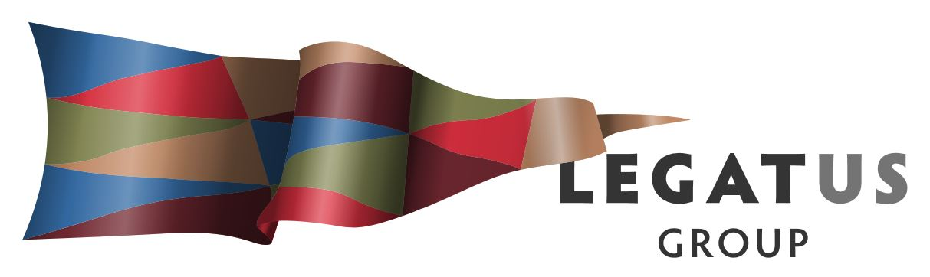

Notes of Legatus Management Group meeting
Friday 3 August 2018 11.00 am District Clare and Gilbert Valleys Council
- ATTENDANCE
  - Present: Colin Byles (Chair), Colin Davies, Peter Harder, Andrew Cole, Martin McCarthy, David Stevenson, Helen Macdonald, Peter Ackland, Kristen Clark, Jason Kuchel and Simon Millcock.
  - Apologies:
Andrew Cameron, Wayne Hart, Brian Carr, Peter McGuinness and James Miller.
- WELCOME
Colin Byles welcomed everyone to the meeting and congratulated the Copper Coast Council on the opening of the Copper Coast Sports & Leisure Centre and the role of Peter Harder and the team at Copper Coast Council. Peter outlined some of the learnings and answered questions.
- PRESENTATIONS
    - Michael Arman Manager LG Emergency Management Planning
Michael provided an overview of the Emergency Management Council Ready Program and the state-wide workshop program assisting with identifying areas that will support the regional officers scheduled for 2019. All Legatus Group councils (except Wakefield) are involved with either one on one workshops or with combined workshops. Michael seeking as many council staff as possible due to the complexity across the whole of council when dealing with emergency management. Wakefield Regional Council will be undertaking a specific response. The findings are due to be finalised by December 2018. Michael acknowledged Legatus Group has sought this regional officer role from past two years ago and have been active in assisting with promoting and coordinating the workshops.
    - Larissa Mackrill Disability Workforce Coordinator RDA Yorke Mid North
Larissa provided an update on the two-year program that is designed to connect disability sector employers and suitable job seekers, support local employers to identify and address their workforce development needs and deliver community engagement activities and information dissemination. Information was provided on the participants and employment progress in the region and it was identified there are deficiencies with local and regional impacts discussed. Larissa acknowledged the work being undertaken in partnership with Legatus Group including the recent socio-economic impacts of NDIS to councils and the upcoming Wellbeing and Disability Forum in Port Pirie. Larissa is seeking assistance from constituent councils by:
- Information & links to be made available on all LGA websites
- Resources & pamphlets in reception offices
- Subscriptions to E-newsletter
- Attendance at upcoming Regional Disability & Wellbeing Forum
- DISCUSSION ITEMS
Legatus Group CEO’s Simon Millcock provided a verbal report on:
- Audit and Risk Management Committee meeting held 3 August 2018 outlining that the committee noted the 2018/2019 budget variation report distributed to all councils. Discussion held on the level of reserves and that subject to the adoption of the 2017/2018 annual report, Colin Davies and the Legatus Group CEO will undertake a review and develop recommendations given that many of these reserves projects have been acquitted.
- Road and Transport Infrastructure Advisory Committee meeting held 2 August 2018 included an update on the current SLRP allocations and commencement of phase 2 of the Regional Transport Plan. Noted that the Legatus Group CEO will be progressing a report on railway crossing safety and the meeting saw value in this work being undertaken. Agreement on value for progressing with report with other organisations on the socio-economic impacts associated with deteriorating condition of Horrocks Highway. The meeting was supportive of the workshops on heavy vehicle access issues.
Legatus Group CEO had provided a written report and general discussion was held on the following topics:
- Community Wastewater Management Schemes – great feedback from the state-wide forum coordinated by Legatus Group in Nuriootpa the week before. The meeting noted that no CEO’s had expressed interest at this stage in the Legatus Group CWMS Committee. Andrew Cole noted that 4G communications and that CWMS are serviced by copper wire.
- Emergency Management - CEO’s were encouraged to consider staff attendance at the workshops.
- Climate Change – including interest around the approach of PhD Interns and waiting on update from the Yorke Mid North Alliance re RDA YMN contribution.
- NDIS socio-economic impact on regional councils – update on the meeting held with LGA Executive to progress discussions with state government agencies and LGA position to be confirmed after metropolitan council’s project is completed.
- Rating Equity – LGA circular has been distributed seeking any further comments from councils by end of August.
- Yorke Mid North Regional Planning Day and Regional Development South Australia Conference.
- LGA R&D funding applications – Digital Maturity and Volunteering projects supported.
- Population Policy for LGA and Legatus Group Region.
- Offer by Legatus Group CEO to assist with grant funding either at whole of region or sub-regional levels for programs such as Healthy Communities and the Regional Growth Fund. CEO’s were encouraged to use the resource of the Legatus Group CEO.

- OTHER BUSINESS

  - LGA Constitution and Auxiliary documents – The meeting noted that the LGA Circular had been distributed that day with an update on the consultation and proposed action by LGA for feedback by 31 August 2018: https://www.lga.sa.gov.au/page.aspx?c=81066

  - Illegal Dumping – Some councils have seen an increase over the past few months and CEO’s invited to bring data to the next meeting for further discussion.

  - Nuclear Waste Dump Hawker – Colin Davies provided an update on the community consultation process.

  - Cost involved with LG Risk Services – Major issue for all councils and meeting saw the value in a specific workshop being held for all CEO’s and appropriate staff to identify the key 4-5 issues that are common across the region. These issues would be of interest to other Regional LGAs and then to SAROC. Worksop to be held prior to the next meeting as stand-alone workshop. CEO’s Helen Macdonald, Jason Kuchel, Peter Ackland and Martin McCarthy to scope out further with Legatus Group CEO.

  - Ambulance services – Jason Kuchel discussed concerns about the level of volunteers and that he would follow up with Ambulance SA. It was noted that Limestone Coast had undertaken some work in this space 7-8 years ago and Jason would follow up.

- CLOSE AND DATE OF NEXT MEETING

The meeting was closed at 2.10 pm and next meeting to be held at District Council of Mount Remarkable 11.00am Friday 30 November 2018.

